Stefan Wojcik 20435347

# Overview

I am going to create a widget that shows when you should leave from your current location (or a specified location) to make it in time for your exams. It will also show you the weather (animated) in the background so you can be prepared in case there is a blizzard! I allow the user to add their own event in case I cannot get their midterm times and dates or they have an in-class pop quiz. I also want the user to be able to search for a location in case google maps doesn’t recognize “ECH 1002”. The user can input “Mathematics and Computing, Waterloo” to guarantee an accurate location.

# Web Services

I will be using api.uwaterloo.ca to get the student’s courses, exam and midterm schedule (this may have to be parsed separately), open weather data, google maps api, and potentially GRT’s real time map. I could also get the student’s grades to see what he/she needs to get on the exam to pass the course (haven’t looked at what we actually get for the grades. This may not be feasible).

I would also like to use Promises (which are an ES6 feature) so I ask to test my widget in Firefox 26 or later.

# Interaction Sequence Diagram

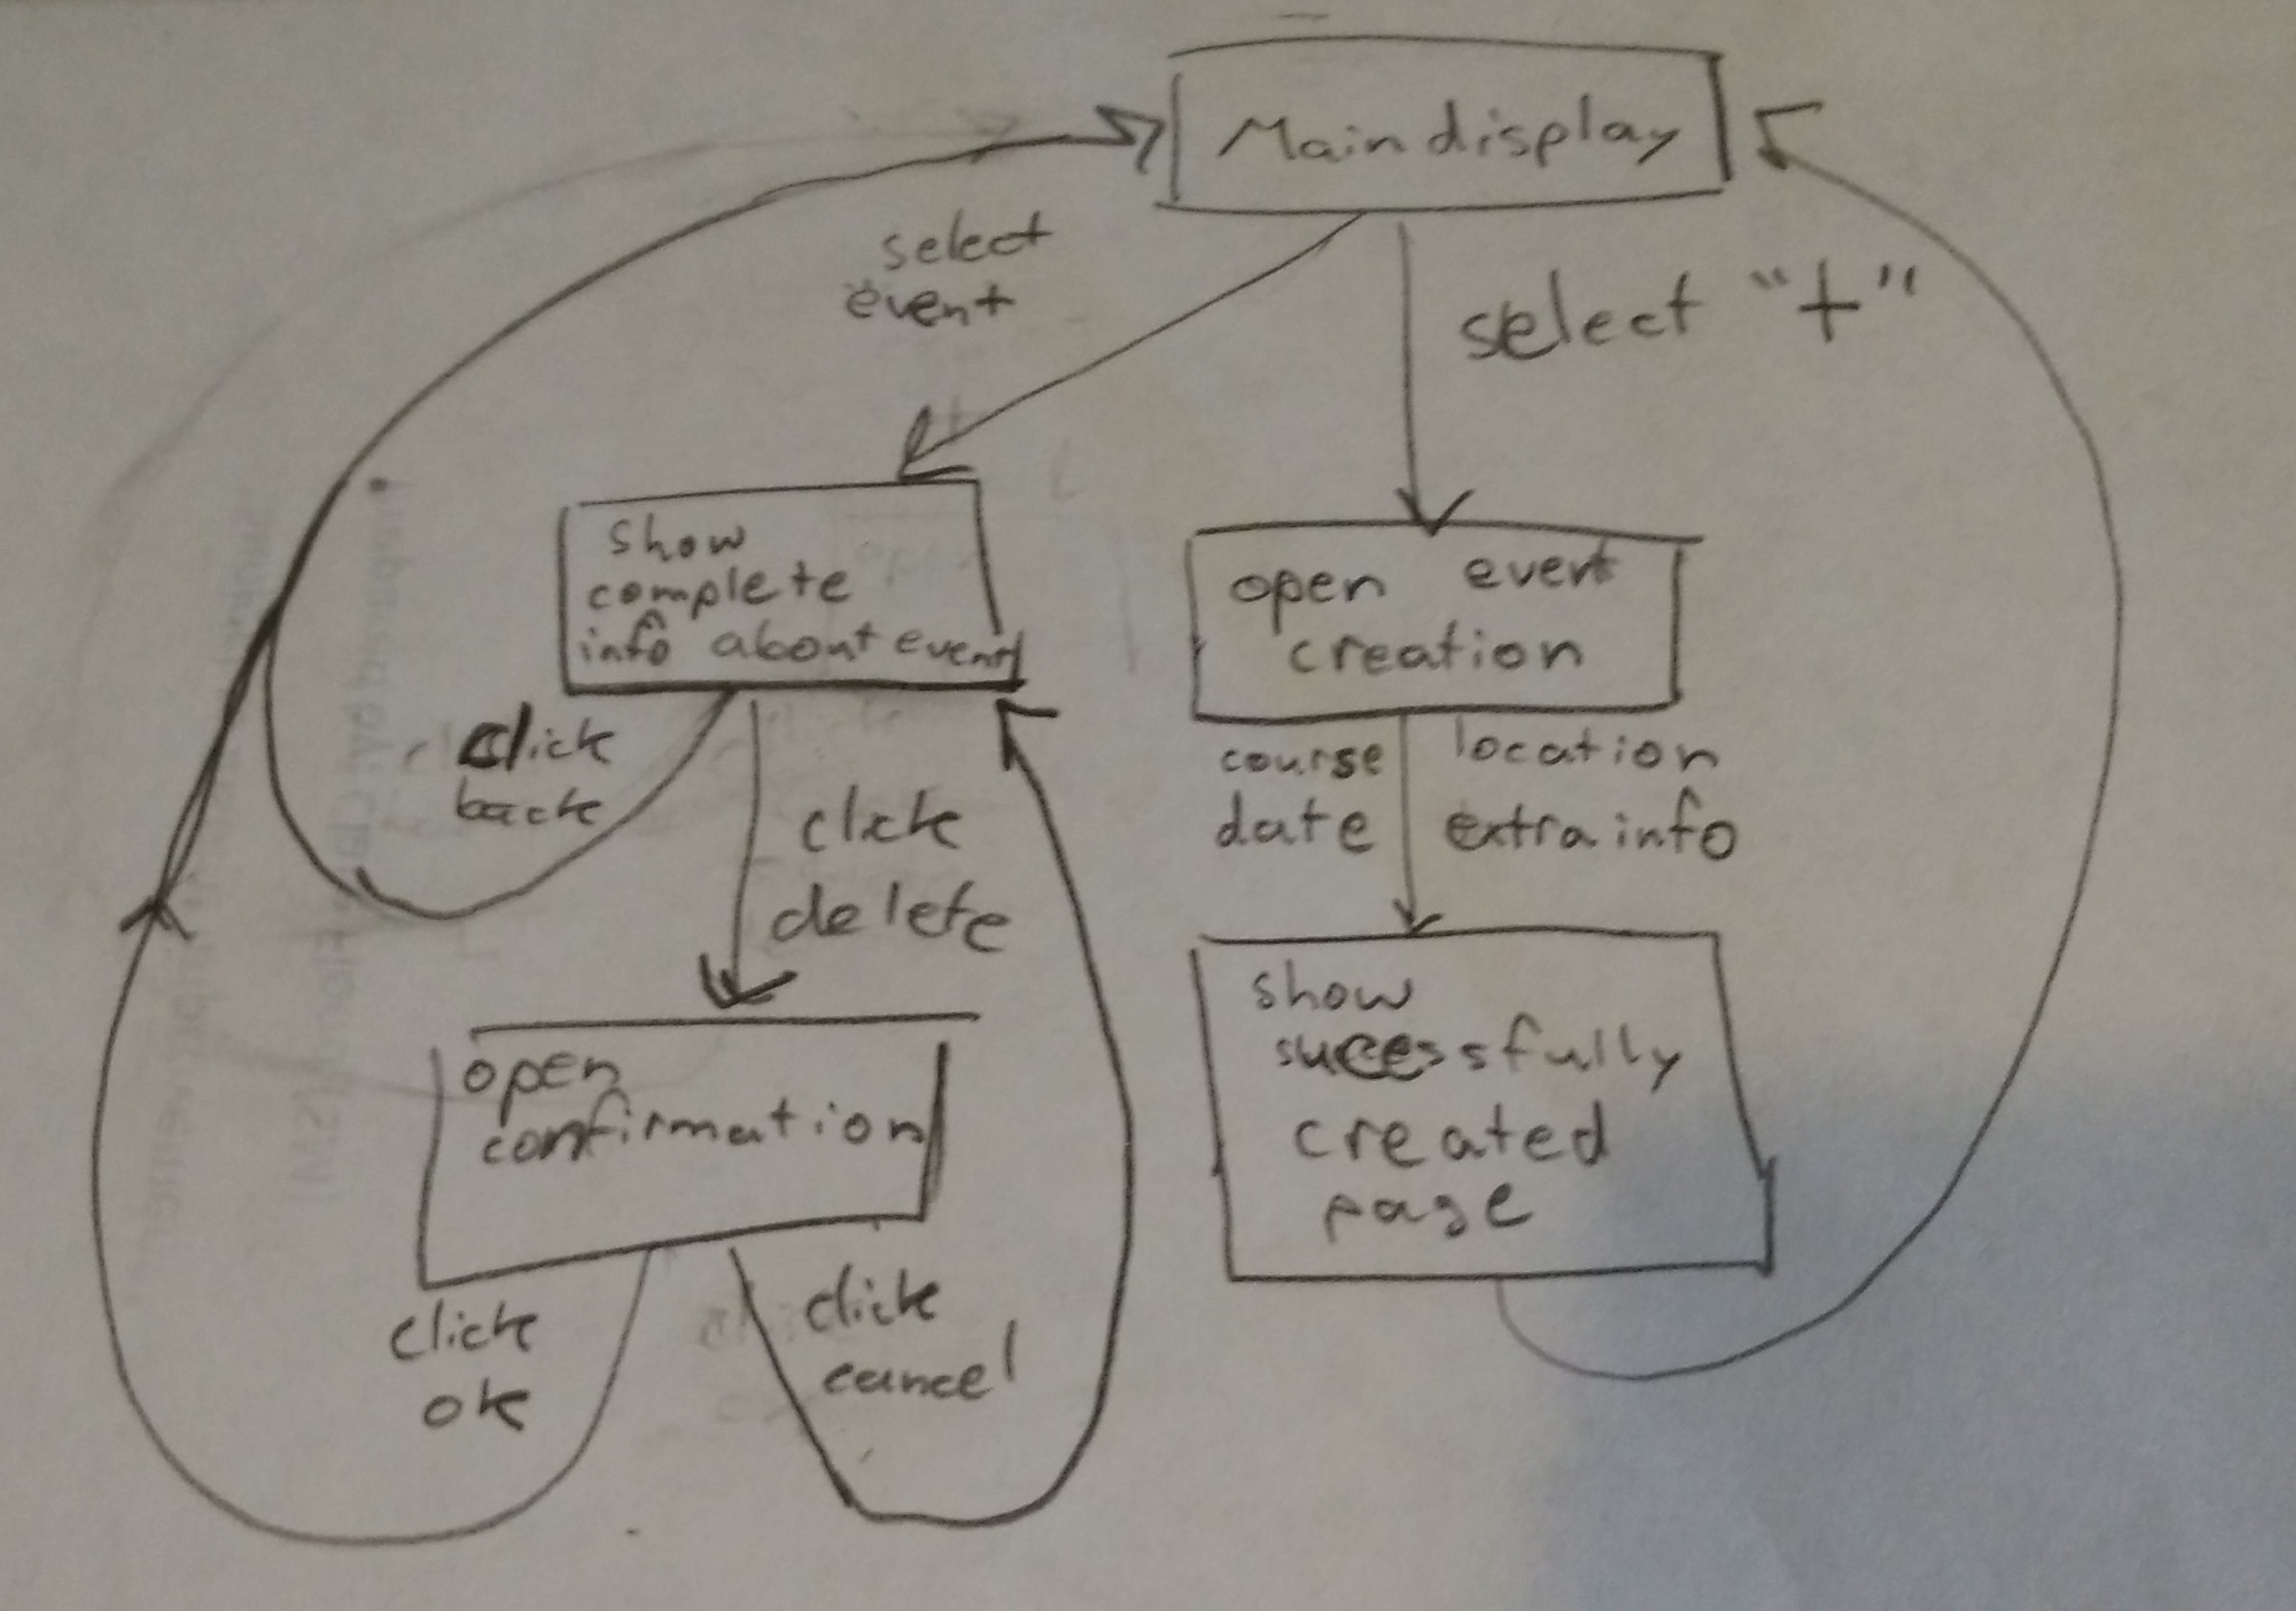

# Interface Schematics

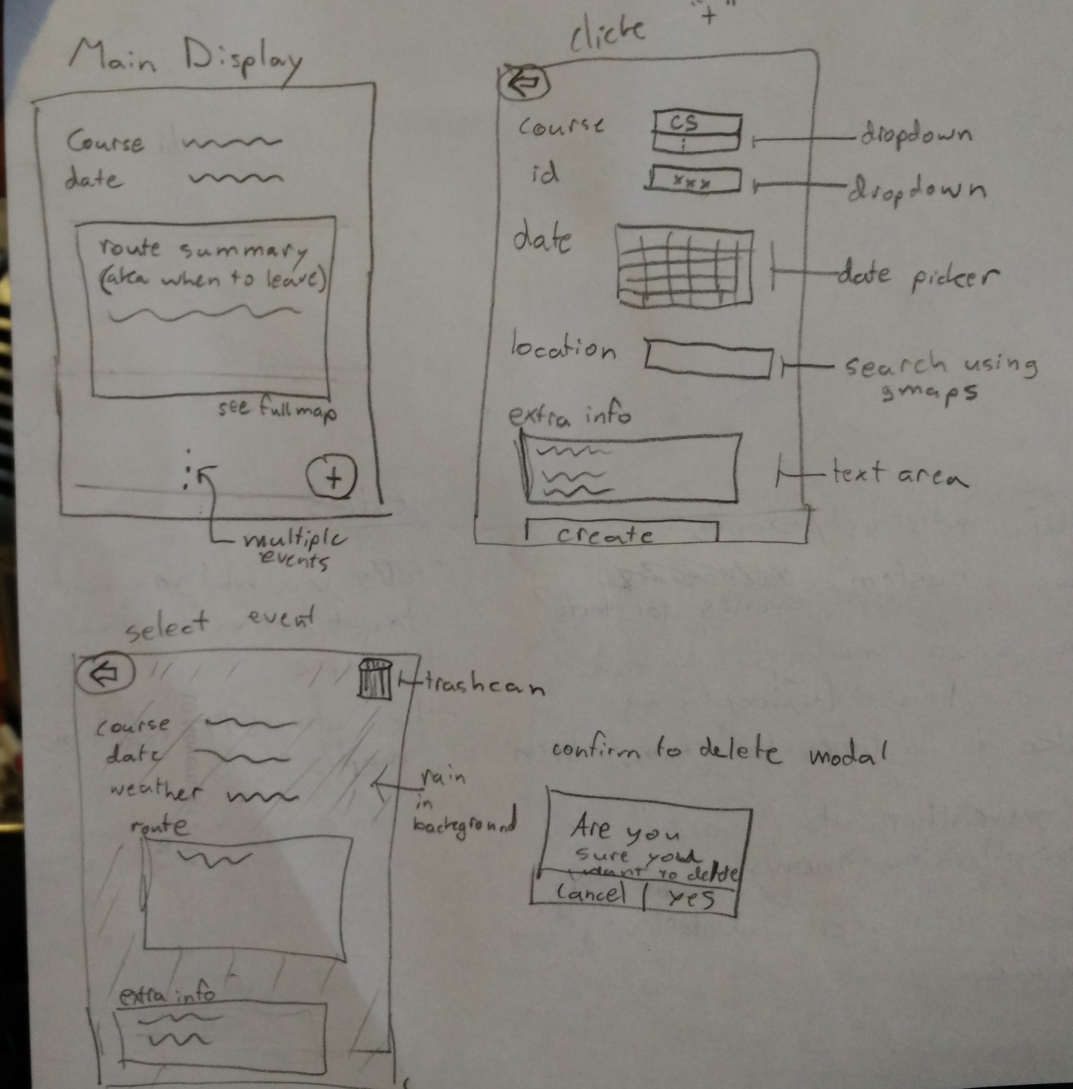

# Challenges

The biggest challenge will be to figure out how to get the current location and tie that into the google maps api. If I have time, figuring out how to use GRT’s new real time map will also be tough (if there is no api).

# Extra Notes

If you think I should add something else that would really make this idea “kick-ass” please let me know! I want to make something that everyone will want to use at uwaterloo, not just me!

# Edit:

Midterms are listed by Quest, so according to your comment, we do not have access to that?

If I can’t get midterm dates then I allow the user to be able to add their own events (which will be their midterms). I also let them add a location because google maps may not accurately get “ECH 1120”, for example, so I allow the user to search for the location (they may need to type the whole name of the building or specify the address).